Survival FPS Shooter Game
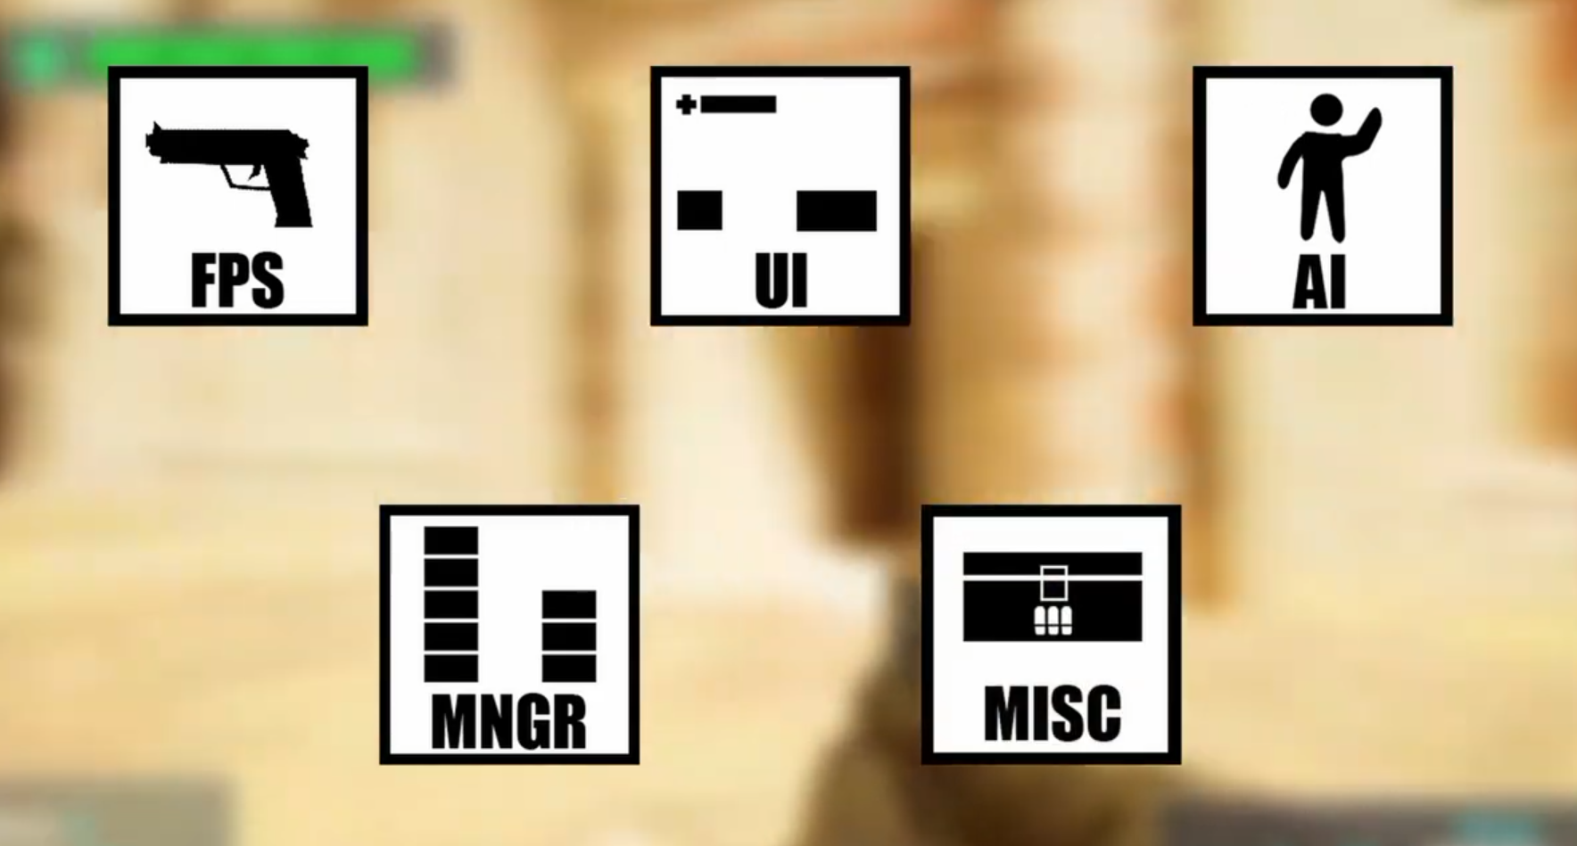
Open unreal engine editor -> First Person Template [with c++]
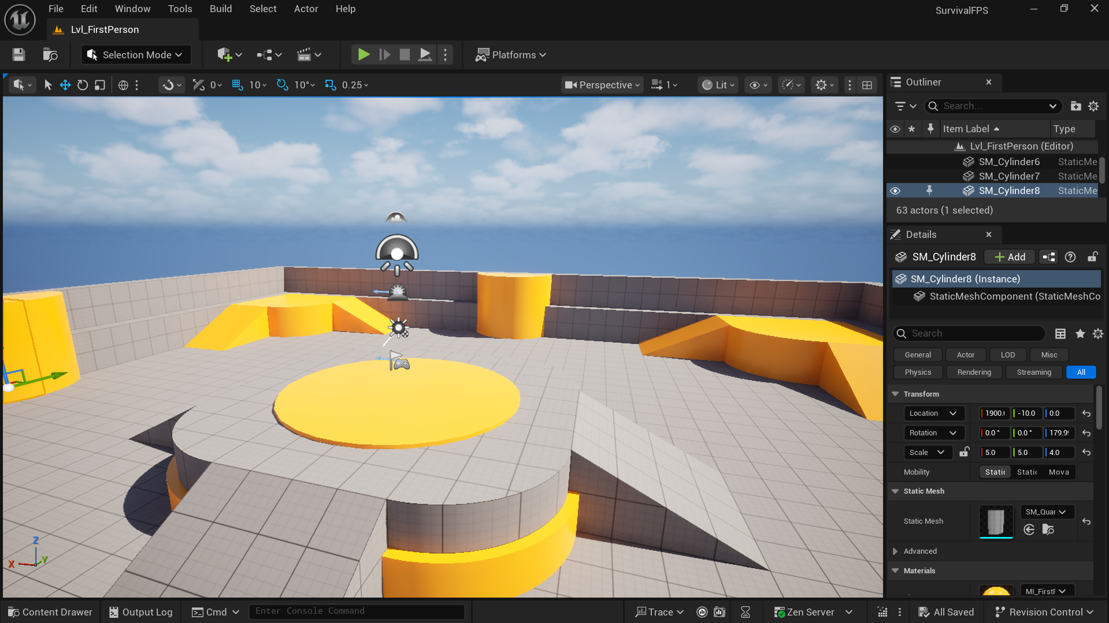
Download the assets from the Fab
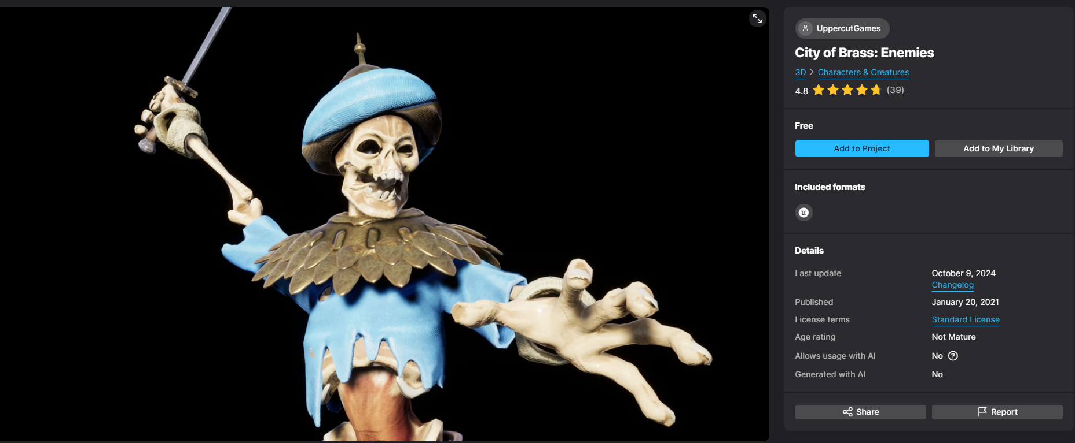
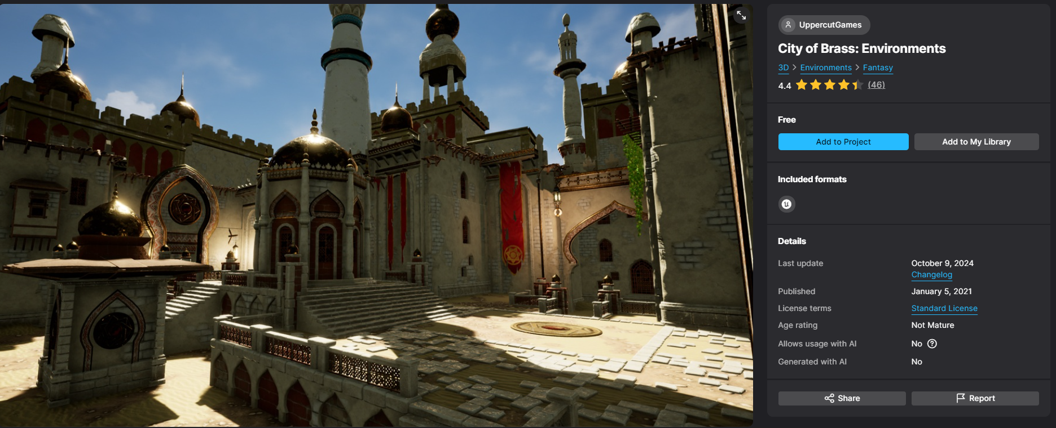
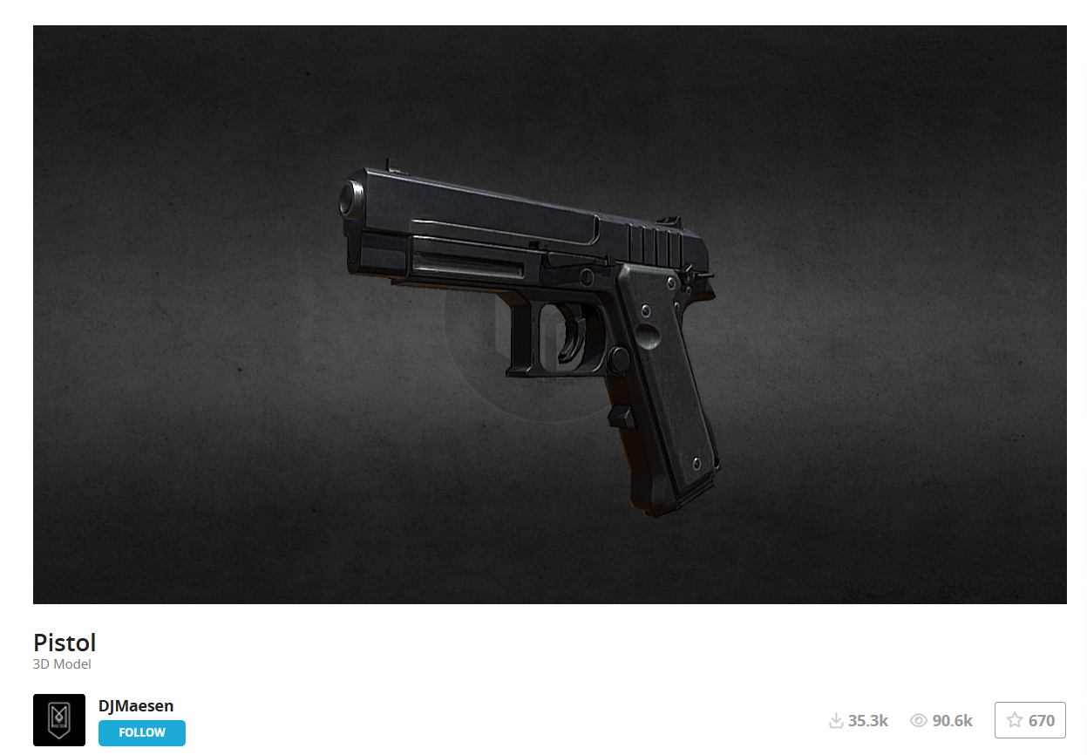
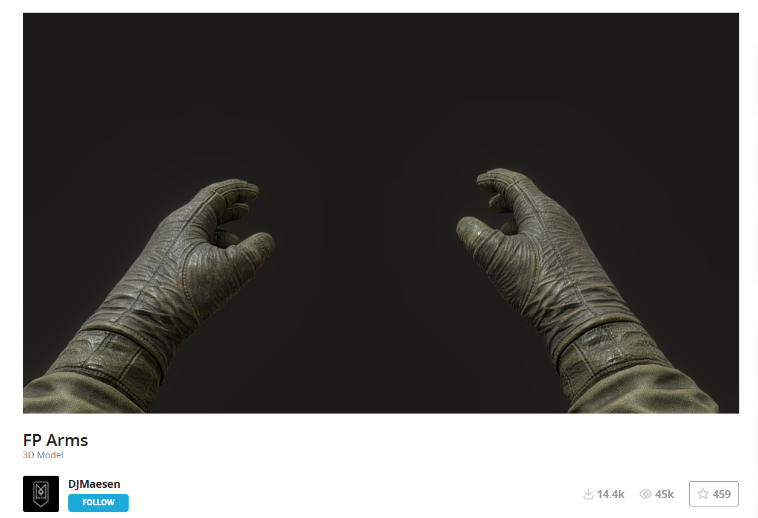
Now just import the assets to the unreal project [most of the asset’s material downloaded from sketch fab has some material issue we need to manually resolve these problem by own-> delete the existing material and create the new material for the mesh accordingly]
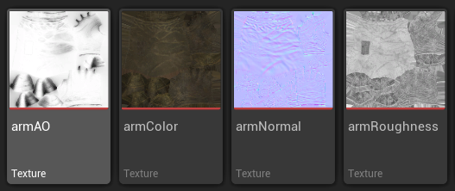
Now create an new material [just assign the Textures to the material as well]

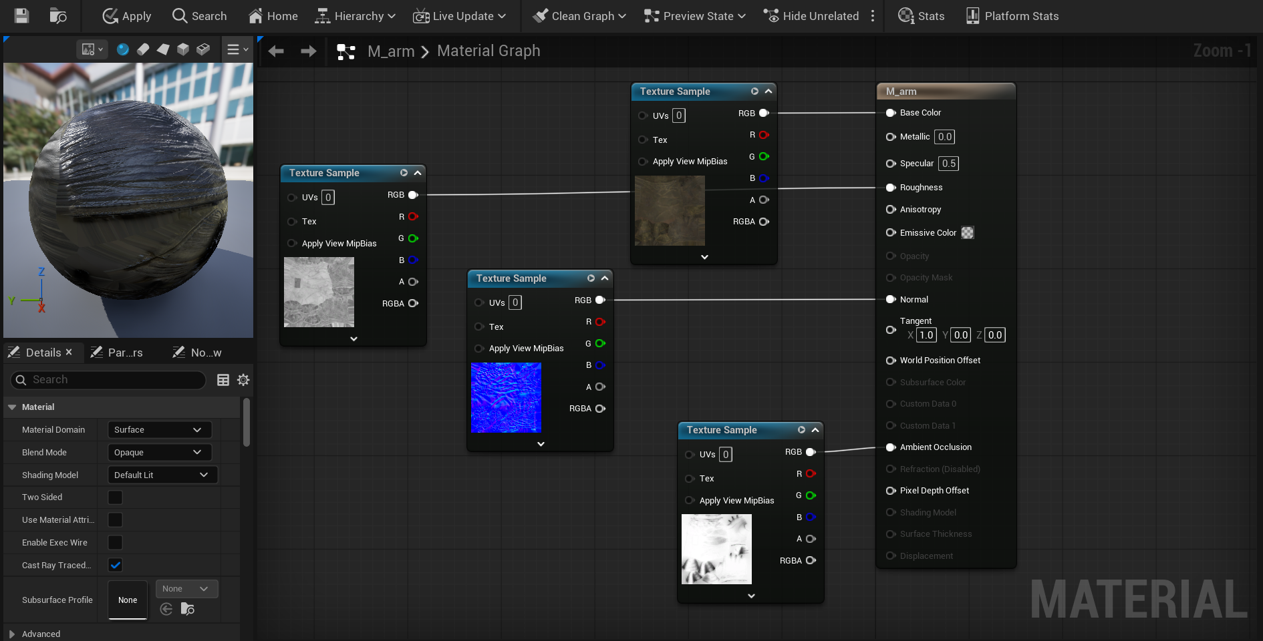
Import the UI and Sound to the content
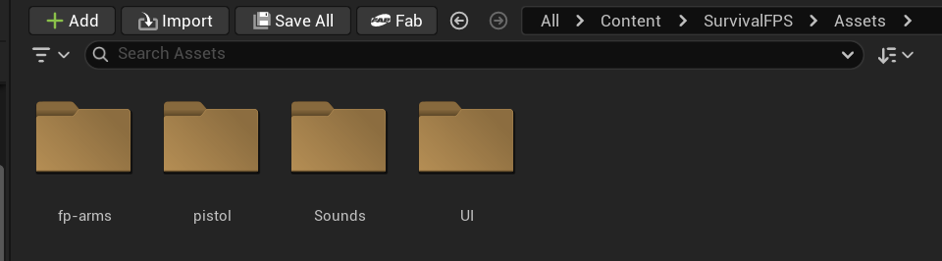
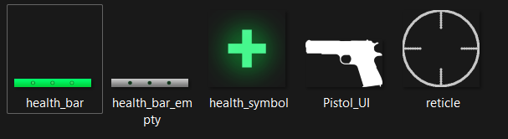
Now adding C++ modules
Open the script SurvivalFPS.Build.cs
// Copyright Epic Games, Inc. All Rights Reserved.
using UnrealBuildTool;
public class SurvivalFPS : ModuleRules
{
public SurvivalFPS(ReadOnlyTargetRules Target) : base(Target)
{
PCHUsage = PCHUsageMode.UseExplicitOrSharedPCHs;
PublicDependencyModuleNames.AddRange(new string[] {
"Core",
"CoreUObject",
"Engine",
"InputCore",
"EnhancedInput",
"AIModule",
"StateTreeModule",
"GameplayStateTreeModule",
"UMG",
"Slate",
"Niagara",
"NavigationSystem",
"GameplayTasks"

});

PrivateDependencyModuleNames.AddRange(new string[] { });
PublicIncludePaths.AddRange(new string[] {
"SurvivalFPS",
"SurvivalFPS/Variant_Horror",
"SurvivalFPS/Variant_Horror/UI",
"SurvivalFPS/Variant_Shooter",
"SurvivalFPS/Variant_Shooter/AI",
"SurvivalFPS/Variant_Shooter/UI",
"SurvivalFPS/Variant_Shooter/Weapons"
});

// Uncomment if you are using Slate UI
// PrivateDependencyModuleNames.AddRange(new string[] { "Slate", "SlateCore" });

// Uncomment if you are using online features
// PrivateDependencyModuleNames.Add("OnlineSubsystem");

// To include OnlineSubsystemSteam, add it to the plugins section in your uproject file with the Enabled attribute set to true
}
}

